

# **GOVERNMENT OF ABIA STATE**

# **MINISTRY OF LANDS AND HOUSING**

Terms of Reference

Consultancy services for “Implementation of the Digital Archive System’’

1. OBJECTIVE

The objective of this consultancy is the implementation of a data centric digital archive of Certificates of Occupancy (CofOs), which fully meets the minimum requirements outlined in section D of this TOR. The digital archive can be implemented using existing commercial or open-source products or as a custom development. The preference should be given to free and open-source platforms, avoiding recurrent license fees. For commercial products a perpetual license should be provided and included in the overall cost.

The Consultant is expected to deliver the digital archive system, introduce it in the Ministry of Lands and Housing, train local staff, handover the system with all relevant documentation and provide technical support services for three months.

1. SCOPE OF WORK

In undertaking the assignment, the Consultant shall work in close collaboration with the Abia State Ministry of Lands and Housing, the SABER Focal person and Abia State Geographic Information System to plan and agree required activities for the implementation of the digital archive system. The specific tasks to be performed are as follows:

* + Review existing workflows, rules and procedures of managing CofO records. It should be noted whether any information system is used for processing CofO records and how it can be potentially integrated with the digital archive system;
  + Review and gather the statistics of CofO paper archives in all Land Administration Offices in order to understand the required hardware to run and operate the digital archive system;
  + Draft technical specifications for computer hardware required for the digital archive implementation. This step can be skipped if the required equipment is available in the Abia State Ministry of Lands and Housing;
  + Consult with the Abia State Ministry of Lands and Housing and prepare the final list of requirements for the digital archive system. It should be the System Requirements Specification (SyRS) in the case of a custom development;
  + Develop and test the digital archive system as per SyRS (for custom development);
  + Prepare user and administration guides on operating and administration of the digital archive system;
  + Introduce the digital archive system in the Abia State Ministry of Lands and Housing for testing and training;
  + Prepare the training plan and program;
  + Deliver user and administrator trainings. It is expected 10 users attending the training;
  + Introduce the digital archive system into production in the Abia State Ministry of Lands and Housing;
  + Handover the system, documentation and source codes (for custom development);
  + Draft the final report;
  + Provide technical support online and offline for [three] months after the system introduction;

1. SYSTEM REQUIREMENTS

The system requirements described below should be considered as a minimum set of system functions and capabilities, required for the implementation. Existing products can deliver more features.

General requirements

1. The system shall allow multiuser access over the network.
2. The system should be a Hybrid Cloud-based application with server-side component, implementing business logic and database access.
3. The system can be supplied as a commercial, open-source or custom development solution.
4. If the system is supplied as a commercial solution, it shall have perpetual licenses for 100 users or more.
5. If the system is supplied as a custom development, the Abia State Ministry of Lands and Housing shall have full ownership rights and unrestricted access to the source code. If a custom development is using any licensed components, it shall be agreed with Abia State Ministry of Lands and Housing prior to using them and a required number of licenses provided, allowing access to 50 users at least.
6. The system shall be supplied with the user and administration guides, as well as system documentation in case of custom development (e.g. database description, system architecture).
7. In the case of a custom development, the supplier shall provide a warranty for 6 months, covering bugs fixing.

Functional requirements

1. The user shall be required to log into the system using the username and password, assigned by the administrator.
2. The main screen shall have a list of folders (or categories or workflow steps) on the left side and relevant list of records on the right side, allowing quick filtering of records in the system.
3. The displayed list of records shall allow sorting by visible columns and ordered by the registration date by default.
4. The list of records shall be displayed in paged format (e.g. 20 records per page) and allow pages navigation.
5. The system shall allow records search by the key attributes (e.g. document type, range of registration dates, CofO number, owner name, folio number, status, etc.).
6. The system shall allow viewing of CofOs and relevant evidences through the search results or by opening it from the main screen.
7. The system may implement workflow steps for the data entry and its processing.
8. The system shall allow capturing various documents and recording it under CofO case. Those have to include, but not limited to:
   1. Certificate of Occupancy (CofO);
   2. Land parcel survey diagram / location map;
   3. Owner’s ID;
   4. Allocation letter, if applicable.
9. All document types shall be defined with relevant metadata fields, which have to include, but not limited to the following:
   1. Document type;
   2. Document date;
   3. Document number;
10. For CofO documents, the following fields shall be captured, but not limited to these fields:
    1. Owner type;
    2. Owner(s) name;
    3. Owner(s) gender (mandatory);
    4. Ownership type;
    5. Property unique ID / Survey number;
    6. CofO issuance date;
    7. CofO registration date;
    8. CofO reference number;
11. The system shall allow scanning and attaching of paper copies. It shall allow selecting file format, scanning resolution, color mode and pages setting (single or multipage). It shall also allow editing of a scanned document, adjusting its brightness/saturation, rotating and cropping scanned images. Native scanner applications can be used, but it shall be integrated with the user interface of the digital archive system;
12. Captured and committed documents shall stay read-only in the system. They can be enabled for editing by a user with a dedicated role and the system should request and record the reason for modification.
13. In the case of multi-department/office access to the digital archive, the system shall allow configuration of user access by department/office. Only records, relevant to user’s department/office shall be displayed and accessible.
14. The system should track the history of record creation and modification, capturing user name, event type, date and time of such events. Recording modified fields and their previous values would be beneficial.
15. Every record shall display its modification log in a simple way.
16. The system shall allow generating of parameterized reports (e.g. by dates), for statistical reports, including, but not limited to the following:
    1. Overall number of CofOs;
    2. CofOs by gender;
    3. CofOs by ownership type;
    4. Captured documents by types;
17. The system shall implement various user roles, defining their access to system features.
18. A dedicated system administration role shall be implemented for managing user accounts and system settings.

Non-functional requirements

1. The system shall be easy to use and require minimum training for the end users.
2. All elements on the page shall have a clear style and proper spaces between them, not overcrowding page and placed into logical groups if needed.
3. Fonts and colors shall be consistent for the same UI elements throughout all pages.
4. Navigation elements shall be clear and help easy navigation between pages.
5. Horizontal scrolls shall be avoided to keep maximum width to 1024 pixels.
6. Form elements, which are not supposed to be modified, shall be displayed in different colors to distinguish from editable elements and be disabled for user input.
7. Before submitting page results, simple fields check shall be done and highlight occurred errors instantly with a clear description or appropriate alert message displayed.
8. Partial page updates shall be implemented where appropriate, to avoid a full- page reload and get faster feedback.
9. DELIVERABLES
   * Technical specification for hardware to run the digital archive system (including, server, computers, scanners, network equipment) [subject to the equipment availability in the Abia State Ministry of Lands and Housing];
   * Digital archive system and its source codes (if custom development);
   * System documentation (user guide, administration guide). Other technical documentation in the case of a custom development (data base catalog, architecture description);
   * Training plan and program;
   * Trainings;
   * Final report;
10. LINE MANAGEMENT

The Consultant shall report directly to the Abia State Ministry of Lands and Housing, through the Secretary to the State Government of Abia State. The Consultant shall closely collaborate with the Directo General Abia State Geographic Information System to elicit system requirements and introduce the system as a major policy reform of the Government of Abia State.

1. PROPOSED TEAM COMPOSITION FOR CUSTOM DEVELOPMENT
   * Team leader / Business Analyst (1);
   * Senior Software Developer (1);
   * Software Developer (1);
   * Tester/Technical support (1);
2. QUALIFICATION AND SKILLS (TEAM LEADER/BUSINESS ANALYST)
   * A master’s degree in Computer Science, business or related field;
   * A minimum of 5 years of proven work experience as a business analyst;
   * Exceptional analytical and conceptual thinking skills;
   * The ability to convince stakeholders and work closely with them to determine acceptable solutions;
   * Proven experience in stakeholder analysis, requirements engineering, costs benefit analysis and processes modeling;
   * Understanding of networks, databases and other IT technologies;
   * Advanced technical skills and knowledge of CASE tools;
   * Experience creating detailed reports and delivering presentations;
   * A track record of following through on commitments;
   * Excellent planning, organizational, and time management skills;
   * Experience leading and developing top-performing teams;
   * A history of leading and supporting successful projects;
   * Experience and knowledge of digital archive systems is an additional advantage;
   * Proficient English and excellent technical writing skills. Ability to write in technical English clear and correct;
3. QUALIFICATION AND SKILLS (SENIOR SOFTWARE DEVELOPER)
   * Masters or similar degree in Information Technology;
   * A minimum of 10 years of proven work experience as a software developer;
   * Managerial experience is an additional advantage;
   * Advanced knowledge of programming languages including JavaScript, HTML5, Java, SQL, ASP.NET and PHP;
   * Knowledge of system frameworks including .NET, Git, AngluarJS;
   * Ability to use version control software such as GIT and SVN;
   * Experience designing and maintaining databases;
   * Experience working with Agile development technologies;
   * Understand emerging web and mobile development models;
   * Experience with digital archive systems is an additional advantage;
   * Proficient English and excellent technical writing skills. Ability to write in technical English clear and correct.
4. QUALIFICATION AND SKILLS (SOFTWARE DEVELOPER)
   * Bachelor or similar degree in Information Technology;
   * A minimum of 5 years of proven work experience as a software developer;
   * Solid knowledge of programming languages including JavaScript, HTML5, Java, SQL, ASP.NET and PHP;
   * Knowledge of system frameworks including .NET, Git, AngluarJS;
   * Ability to use version control software such as GIT and SVN;
   * Experience designing and maintaining databases;
   * Experience working with Agile development technologies;
   * Experience with digital archive systems is an additional advantage;
   * Proficient English and excellent technical writing skills. Ability to write in technical English clear and correct.
5. QUALIFICATION AND SKILLS (TESTER/TECHNICAL SUPPORT)
   * Bachelor or similar degree in Information Technology;
   * Five years of proven knowledge and experience in performing system and performance testing;
   * Knowledge of best practices, methodologies and tools for conducting testing;
   * Experience in preparation of test plans;
   * Experience with Microsoft .Net, Java and databases;
   * Experience of similar assignments in 3 different projects;
   * Experience in providing technical support;
   * Experience with digital archive systems is an additional advantage;
   * Proficient English and excellent technical writing skills. Ability to write in technical English clear and correct.
6. DURATION OF THE ASSIGNMENT

The assignment will be fully implemented in [three (3)] months, starting from the contract signing date; and will be primarily conducted on behalf of Abia State Government.

1. INPUTS BY THE CLIENT

The Abia State Ministry of Lands and Housing will provide the Consultant with all available information and materials, relevant to the implementation of the digital archive system. The Client will provide access to the paper archive for their review and quick assessment.

The Client will provide required equipment for the installation and testing of the digital archive system and arrange office space for conducting user trainings.

The Client will assist in arranging required meetings and delegate a focal person to work with the Consultant. If required, the Client will provide an adequate office space, located at the Abia State Ministry of Lands and Housing premises.

1. REPORTING REQUIREMENTS

All reports will be shared with the management of the Abia State Ministry of Lands and Housing through the Secretary to the State Government of Abia State. Reports shall be delivered in electronic form and hard copies for the final versions. Comments, provided by the Client will be discussed at virtual and physical meetings. Required report amendments will be incorporated not later than 2 weeks after receiving these comments.

# Appendixes

Appendix 1: Digitization Stages/Workflow:

The digital archive system will be built with a MERN Stack application that will be housed in an on-premises server with a failover repository in an online dedicated Cloud server. The server will be thoroughly encrypted, and the necessary Cloud firewall and physical Cisco firewall put in place. The archive will be indexed and

searchable through key alpha-numeric data and a unique identifier number. Detailed below are the stages, relevant desks and processes to be engaged during the digitalization process and database maintenance.

|  |  |  |  |  |
| --- | --- | --- | --- | --- |
| STAGE | TEAM/DESK RESPONSIBLE | TASK(S) | DELIVERABLE | EST. TIMELINE |
| Project Design/Pl anning | DG, Abia State Geographic Information Service | * Review existing CofO process and document system to inform the design and business process for   proposed digital archive. | Baseline assessment and system improvement  report. | 1 Month |
|  |  | * Develop digitization plan in consultation with relevant stakeholders/MDAs. The plan will cover all requirements including business process engineering, ICT infrastructure, change management, maintenance, etc. | Approved digitalization plan |  |
|  |  | * Develop ToR and procurement plan. | Approved ToR and Procurement  Plan |  |
|  |  | * Cost plans and develop a budget for project execution. | Approved project  budget |  |
| Assignme nt of operation  al space | Hon. Commissioner/ Permanent  Secretary | * Assignment of operational space for digitalization operation and data/server   room | Assigned operational space | 1 Month |
| Deployme nt, configurat ion, and installatio n of the digitalizati on system | Consultant/IT Coy | * Procurement, deployment, and installation of all software and hardware required for the digitalization system. | Digitalization system – digital archive application, hardwares, etc. | 2 Months |
| * Configuration of the system including business process integration, access control definition, data security   parameters. |
| Documen t sorting, arrangem ent, and preparatio n for scanning | Head ABGIS, Clerks, Ministry of Lands Support Staff, Critical staff of Ministry of Science & Technology | * Document review and sorting, ensuring folders contain all relevant information including Certificate of Occupancy (CofO), Land parcel survey diagram / location map, Owner’s ID, and Allocation letter (if applicable). This include repairing worn- out/age-weakened documents/folders. | Reviewed and sorted CofO documents/fol ders by index checklist | 2- 3 Months for clearing backlog while subsequent documentation is reviewed and sorted upon processing. |

|  |  |  |  |  |
| --- | --- | --- | --- | --- |
|  |  | * Arrange documents with index tags using indexing   checklist. |  |  |
| Scanning And Digitizatio n | Data entry operators, ICT technicians | * High-resolution scanning of documents reviewed and sorted by index checklist. Scanning is based on the following requirement.   + Format: PDF   + scanning color: Grayscale 8-bit   + Scanning DPI: 150DPI for good quality documents, 300DPI for poor quality documents,   + One multipage document (PDF) per physical document.   + Meta data assignment | Documents scanned for data entry. | 2- 3 Months for clearing backlog while subsequent documentation is digitalized upon processing. |
| Data Entry | Data Entry Operators, Land Record Managers | * Indexing, feeding metadata and all needed to the document management system. Searchable fields will include Owner type (For example, corporate entity/private individual); Owner(s) name; Owner(s) gender; Ownership type (e.g., single owned; joint/co-owned between man and woman); Property unique ID; CofO issuance date; CofO registration date; CofO reference number (a certificate or document number that matches the number on the physical   record) | Digitalized CoF O records according to indexing and meta data checklist as well as unique identifiers | 2- 3 Months for clearing backlog while subsequent documentation is digitalized upon processing. |
| * Automated unique identifiers are assigned, ensuring the indexed information for each CofO will be linked to a scan of the respective paper   documents |
| Storage and Managem ent | IT Specialist, Database Administrator, Data Center Manager | * Implement backup and disaster recovery measures including periodic system, data and information security audits | Robust data storage and security | 2 months |
| * Preservation and maintenance of physical   archives | Real-time |
| Documen t  manage ment | DG, ABGIS Consultant, ABGIS Records Managers, IT  Support, | * Configure access controls (including API) and permissions for document   retrieval protocols to support | Access controls and APIs assigned | Real-time |

|  |  |  |  |  |
| --- | --- | --- | --- | --- |
|  |  | data sharing. |  |  |
| * Day-to-day administration of EDMS application as well as periodic updates and monitoring of applications   and records on the backend | Optimal and updated EDMS | Real-time |

# Appendix 2: Snapshot of the Database Schema

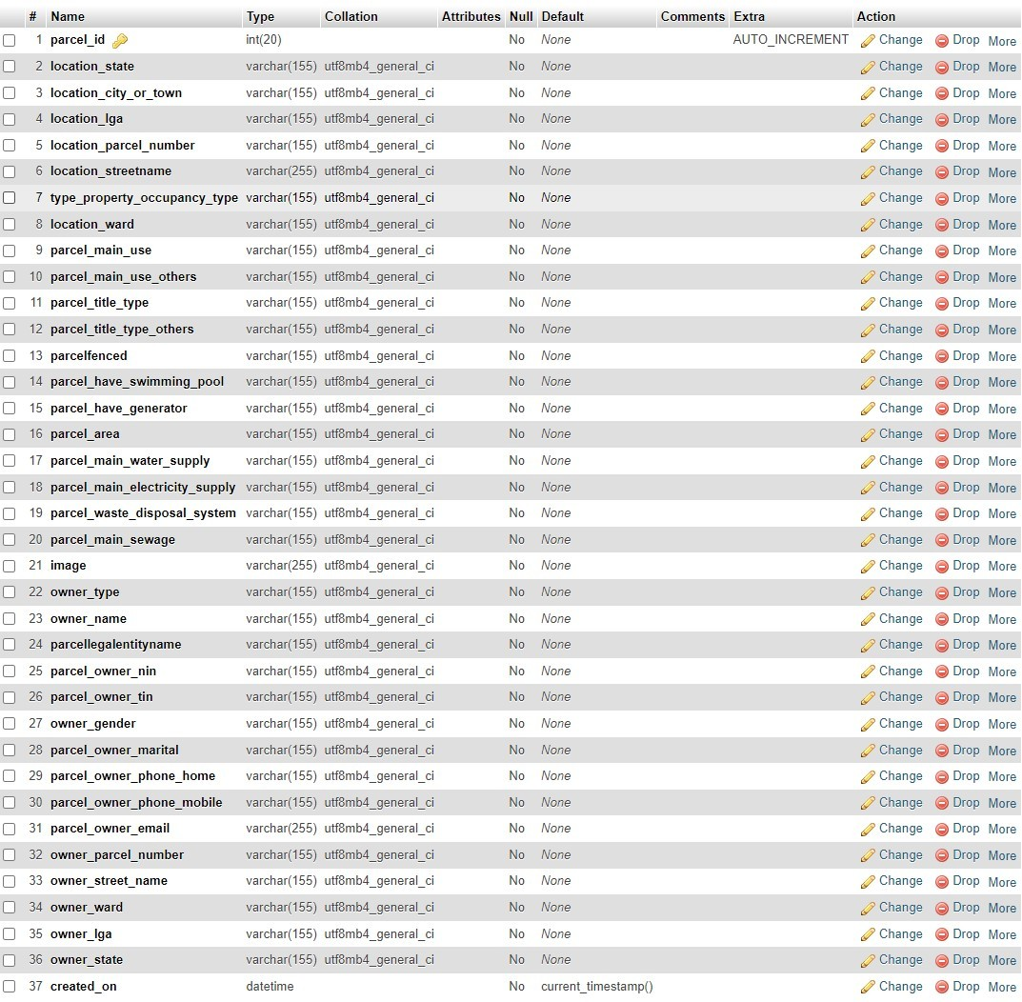

*The table above depict the snapshot of the database schema.*

Appendix 3: ABIA STATE GOVT Digital Archiving System

