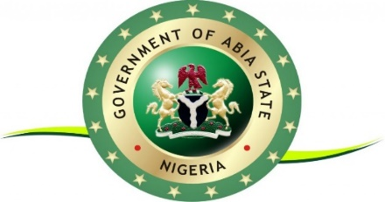

**ABIA STATE MINISTRY OF TRANSPORT**

GUIDELINES, TIME AND COST ASSOCIATED WITH OBTAINING DRIVERS LICENSE IN ABIA STATE

**O V E R V I E W**

A driver’s license is a legal document issued by the Federal Road Safety Commission

(FRSC) that confers the right to drive to an individual. In accordance with the

Federal Road Safety Commission (Establishment) Act, 2007’ Section 5(h). Anyone

older than 18 years old is eligible to obtain a driver’s license in Nigeria who wants to

obtain driver’s license must follow the guidelines below:

|  |  |  |  |
| --- | --- | --- | --- |
| S/N | PROCEDURES | TIME TO  COMPLETE | ASSOCIATED COST |
| 1 | Obtain Driving School Certificate Agency: Accredited Driving Schools Attend training at an accredited driving school licence | 30 days | At the discretion of the Agency |
| 2 | Complete the driver’s license application form online. Agency: Federal Road Safety Service Commission Complete the driver’s license application form at the Drivers Licensing DLC or apply online at https://www.nigeriadriverslicence.org/. Application form is free | 1 day | No charge |
| 3 | Driving Test Agency: Once you pass the driving test, you will be given a certificate of proficiency by the Driving School. Present your driving certificate to the Vehicle Inspection Officer (VIO) for a driving test. If you pass the test, you will proceed to the next step. Immediate Temporary License of 3 months duration will be issued to you | 5 days | No charge |
| 4 | Pay the license fee online or at designated Bank. Agency: Federal Road Safety Service Commission (FRSC) & FIRSC Designated Banks. If you applied online, print your acknowledgement slip once the payment is verified. The link to the online payment at https://www.nigeriadriverslicence.org/ under Apply | 1 day | NGN15,000 for 5 Years Driving License certificate & NGN10,000 for 3 years Driving License certificate |
| 5 | Confirm payment at Imo State Internal Revenue Services Agency: Imo State Internal Inland Revenue Services. Present your application form/slip to the Imo State Internal Inland Revenue (BIR) Officer and VIO at the DLC for endorsement. Proceed to the FRSC office at the DLC for endorsement | 1 day | No charge |
| 5 | Proceed to the FRSC office at the DLC for biometric data capturing Agency. | 1 day | No charge |
| 6 | Visit Imo State DLC/MLA and present your application form or temporary card to pick up your original license card Agency: | 60 days | No charge |

**FOR ENQUIRIES CALL CUSTOMER CARE UNIT ON: OR VISIT MINISTRY OF TRANSPORT NEW GOVERNMENT SECRETARIAT, OGURUBE LAYOUT, UMUAHIA.**

**Signed**

**Commissioner for Transport**