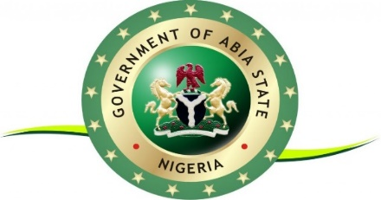

OFFICE OF THE GOVERNOR

**Executive Order on the Promotion of Transparency and Efficiency in the Business Environment**

AN ORDER DIRECTING BUSINESS ENABLING ENTITIES IN THE STATE TO PUBLISH ALL RELEVANT INFORMATION ON FEES, PROCEDURES, SERVICE LEVEL AGREEMENTS (SLAS), GRIEVANCE REDRESS MECHANISM (GRM) FOR ALL CORE BUSINESS REGULATORY PROCESSES PROVIDED BY THEM

Pursuant to the Abia State policy on transparency, efficiency, and accountability in government to -business services provided by various State Business Enabling Ministries, Departments, and Agencies (MDAs).

NOW, THEREFORE, I, Dr Alex Chioma Otti, Executive Governor of Abia State in exercise of the powers conferred upon me by the 1999 Constitution of the Federal Republic of Nigeria and other relevant laws, do hereby issue this Executive Order:

1. Publication of Information on State Website(s)

The under listed Ministries, Departments and Agencies of the Abia State government among others shall publish on the state official website(s) all relevant information on fees, procedures, Service Level Agreements (SLAs), Grievance Redress Mechanism (GRM) for all core business regulatory processes provided by them, and advance communication rules of upcoming changes to the information on any of their business processes and activities as mentioned above and such changes shall come into effect only after a minimum of 30 days after the date of notice of the changes

1. The Business Entities referred to in 1 above but not limited to them are:
2. Ministry of Land and Housing
3. Abia State Environmental Protection Agency
4. Abia State Internal Revenue Service
5. Ministry of Transport
6. Ministry of Trade and Investment
7. Abia State Investment Promotion Agency, etc
8. Abia State Water and Sewerage Corporation
9. Ministry of Industry and SMEs
10. These Ministries and Agencies of government shall maintain dedicated, verifiable and functional contact information during working hours
11. This Executive Order shall come into effect from 21st March,2024

IN WITNESS WHEREOF, I have hereunto set my hand and caused the seal of Abia State to be affixed this 2nd day of March in the year 2024

Dr Alex Chioma Otti

Executive Governor of Abia State