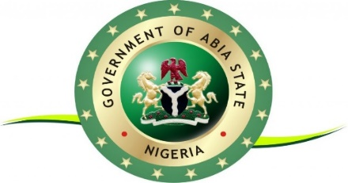

OFFICE OF THE GOVERNOR

EXECUTIVE ORDER NO. OF 2024

RIGHT OF WAY CHARGES ON TELECOMMUNICATIONS

INFRASTRUCTURE

1. This Regulation may be cited as the Abia State Right of Way Executive Order, 2024.

2. This Regulation shall come into effect on the 31st day of March 2024

3. The Regulation is binding upon all State-level MDAs

.

**NOW THEREFORE, I, DR ALEX OTTI, EXECUTIVE GOVERNOR OF ABIA STATE, BY AUTHORITY VESTED IN ME BY THE 1999 CONSTITUTION OF THE FEDERAL REPUBLIC OF NIGERIA AND THE LAWS OF ABIA STATE, HEREBY ORDER AS FOLLOWS:**

**4. ESTABLISHMENT OF ROW REGULATION**

**a.**  There is hereby established for the State an Executive Governor’s Order to be

known as the Abia State Right of Way (ROW) Regulation

b. The ROW Order shall be a binding Regulation of the State, by its provision has set

and adopted an aggregate ROW fee capped at a maximum of N145 per meter for

fibre optic deployment in the State

**5 PURPOSE**

a. The purpose of this ROW Regulation is to establish a State Regulation to adopt

harmonized and standardized aggregate fee for obtaining ROW by relevant entities

6. **OBJECTIVES**

1. The primary objective of the ROW Regulation shall be to help the State improve the regulatory environment for driving private sector investment in digital infrastructure, and create a regulatory framework that will establish and sustain aggregate per-linear-meter fees for fiber deployment (across all State-level MDAs) capped at a maximum of NGN145 per meter
2. In seeking to achieve its objectives, the Ministry of Works shall:

i Be the coordinating Ministry for all ROW activities in the State;

ii. Develop, supervise and implement ROW implementation framework guidelines, processes and procedures

Iii. Ensure that the Regulation for obtaining ROW in the State are in accordance with prevailing State and Federal Government Policy and public interest on digital infrastructure development in Abia State

7. **Mode of payment**:

All ROW related fees shall be paid into the Abia state TSA Account for payment (Access Bank-0006194075) available in all commercial banks nationwide

8. **The entities licensed to obtain ROW in the State**:

In line with Section 31 of the 2003 Nigerian Communications Act (NCA), entities that are licensed to deploy fiber typically include:

1. Licensed Mobile Network Operators (MNOs)
2. Licensed Internet Service Providers (ISPs)
3. Licensed Technicians

**DATED this 16th day of March 2024**

**DR ALEX CHIOMA OTTI**

**EXECUTIVE GOVERNOR OF ABIA STATE**