OFFICE OF THE AUDITOR-GENERAL
FOR LOCAL GOVERNMENTS
LOCAL GOVT. AUDIT HEADQUARTERS
PRIVATE MAIL BAG 7030
UMUAHIA, ABIA STATE
Fax: 088-221621
GSM: 08033923315
09026442662
Email: logauditabia@gmail.com
Net: www.logauditabia,ngr.org

LOGAUD/AR.01/UKE/06 June 27, 2022

The Executive Chairman
Ukwa East Local Government
Akwete

AUDIT INSPECTION REPORT OF UKWA EAST
LOCAL GOVERNMENT FOR THE YEAR, 2021

The following observation arising from a recent Audit Inspection of the Accounts, books, and records of Ukwa East Local Government for the year 2021, are forwarded for your comments, and necessary actions as appropriate, please.

BANK RECONCILIATION
2. It was observed that none of the three (3) bank accounts maintained by the council as stated below were reconciled:

Bank Name | A/c No. | Amount  N
UBA | 1020037568 | 9,809.11
FIRST BANK | 2034380369 | 946,326.60
FIRST BANK | 2034374308 | 19,653,626.85

Your attention is drawn to Model Financial Memoranda 19:24 which state that any account(s) maintained by the council must be reconciled monthly.
Would you please, direct the Treasurer to ensure that the said bank accounts are reconciled and forward copies to me without delay.

REVENUE RECOVERED AT THE INSTANCE OF AUDIT
3. Appendix ‘A’ to this report shows a total sum of N11,500.00 representing revenue recovered at the instance of Audit from revenue collectors in Ukwa East Local Government.

UNRETIRED ADVANCES
4. Appendix ‘B’ to this report shows a total sum of N10,037,900 representing unretired operational advances as at December 31, 2021. It was observed that some of these unretired operational advances had lingered for years. Please, would you ensure cash recovery of the amounts against the affected officers.
Your attention is drawn to Financial Memoranda (FM) 14:26&27 for compliance.

INCESSANT HIRE OF VEHICLE
5. The payment vouchers in Appendix ‘C’ to this report amounting to N1,325,000.00 shows huge amount of money wasted on hire of vehicle by the key officers of the Local Government. Audit observed that the amount spent on hire of vehicle by officers who have official vehicles would have been used to acquire more vehicles through installmental payments by the Government.
Would you please, ensure that such incessant hire of vehicle did not continue in the council and make necessary effort to secure official vehicles to the council, instead of wasting money on hiring of vehicle.

GENERAL CONDUCT OF INTERNAL REVENUE
6. The Internally Generated Revenue of Ukwa East Local Government was in poor performance ratio. A total sum of N11,500.00 represent revenue recovered at the instance of Audit from revenue collectors in Ukwa East Local Government.
ASSETS AND INFRASTRUCTURE
7. The Assets Register of Ukwa East Local Government were incomprehensive. There are many infrastructure decay in Ukwa East Local Government.

PREVIOUS AUDIT REPORT (2020)
8. Particular attention on unretired advances and incessant hire of vehicles. It was observed that despite the previous Audit Report on the issues of untried advance and incessant hire of vehicles, this 2021 Audit Report shows a total sum of N10,037,900.00 representing unretired operational advances as at December 31, 2021 and also N1,325,000.00 which represent amount of money on hire of vehicles.

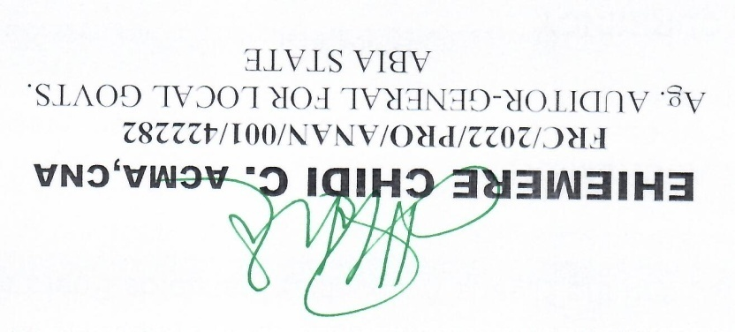

REVENUE RECOVERED AT THE INSTANCE OF AUDIT

Appendix ‘A’
S/NO | NAME | RECEIPT NO | DATE | AMOUNT  N
1. | Baba Godfrey | 0034654 | 11-5-22 | 2,000.00
2. | Otuka Moses | 0034651 | 10-5-22 | 2,000.00
3. | Otuka Moses | 0034658 | 24-5-22 | 3,000.00
4. | Azubuike Chibuike | 0034652 | 10-5-22 | 2,000.00
5. | Ekeke Okere | 0034659 | 24-5-22 | 1,000.00
6. | Nwankwo Ikechukwu | 0034657 | 12-5-22 | 1,500.00
 |  |  |  | 11,500.00

OUTSTANDING ADVANCES AS AT DECEMBER 31, 2021

Appendix ‘B’
S/NO | FOLIO NO | NAME | AMOUNT  N
1. | 6 | Eric O. Ugbor | 3,150,000.00
2. | 14 | Akpara Julius | 102,000.00
3. | 20 | Doreen Nwankwu | 56,000.00
4. | 46 | Goddy Okorafor | 20,000.00
5. | 50 | Kelechi Nwah | 50,000.00
6. | 55 | Roseline Iheanacho | 150,000.00
7. | 57 | Nwaji Okoro | 40,000.00
8. | 68 | Blessing George | 10,000.00
9. | 74 | Nwaha Chukwuma | 20,000.00
10. | 75 | Nnata Prince | 5,000.00
11. | 84 | Prisca Nwaji | 15,000.00
12. | 87 | Ejinwa Christian | 200,500.00
13. | 96 | Maxwell Ahukwe | 40,000.00
14. | 107 | Okere Chunedum | 38,400.00
15. | 113 | Hon. Hector Nwahunna | 601,500.00
16. | 115 | Hon. Akarhu Joe | 592,000.00
17. | 117 | Hon. Sunday Emmanuel | 575,000.00
18. | 119 | Hon. Ibekewum Aguzieudu | 560,000.00
19. | 121 | Hon. J. Obinna | 466,000.00
20 | 123 | Hon. Iheanacho Hyacinth | 466,000.00
21. | 125 | Hon. Aja Uchenna | 466,000.00
22. | 127 | Hon. Ukatta Martins | 466,000.00
23. | 129 | Hon. Reginah Godwill | 466,000.00
24. | 131 | Hon. Dinne Rowland | 466,000.00
25. | 133 | Hon. Johnson D. | 466,000.00
26. | 135 | Hon Ekeke Chidozie | 466,000.00
27. | 147 | Hon. Charles Dinne | 50,000.00
28 | 172 | Endwell Nwadiko | 40,000.00
 |  | Total | 10,037,900.00

INCESSANT HIRE OF VEHICLE

Appendix ‘C’
S/NO | NAME | P.V NO & DATE | PURPOSE | AMOUNT  N
1. | Hon. Chuks Wabara Ex. Chairman Ukw E. | P.V No. 20 of Jan, 2021 | Hire of vehicle | 50,000.00
2. | Hon. Chuks Wabara Ex. Chairman Ukw E. | P.V No. 29 of Jan, 2021 | -do- | 75,000.00
3. | Hon. Chuks Wabara Ex. Chairman Ukw E. | P.V No. 30 of Jan, 2021 | -do- | 75,000.00
4. | Hon. Chuks Wabara Ex. Chairman Ukw E. | P.V No. 31 of Jan, 2021 | -do- | 75,000.00
5. | Hon. Chuks Wabara Ex. Chairman Ukw E. | P.V No. 32 of Jan, 2021 | -do- | 75,000.00
6. | Hon. Chuks Wabara Ex. Chairman Ukw E. | P.V No. 33 of Jan, 2021 | -do- | 75,000.00
7. | Hon. Chuks Wabara Ex. Chairman Ukw E. | P.V No. 34 of Jan, 2021 | -do- | 75,000.00
8. | Hon. Chuks Wabara Ex. Chairman Ukw E. | P.V No. 35 of Jan, 2021 | -do- | 75,000.00
9. | Hon. Chuks Wabara Ex. Chairman Ukw E. | P.V No. 36 of Jan, 2021 | -do- | 75,000.00
10. | Hon. Chuks Wabara Ex. Chairman Ukw E. | P.V No. 39 of Jan, 2021 | -do- | 75,000.00
11. | Hon. Chuks Wabara Ex. Chairman Ukw E. | P.V No. 14 of Mar., 2021 | -do- | 75,000.00
12. | Hon. Chuks Wabara | P.V No. 32 of Mar., 2021 | -do- | 75,000.00
13. | Hon. Chuks Wabara | P.V No. 33 of Mar., 2021 | -do- | 75,000.00
14. | Hon. Chuks Wabara | P.V No. 34 of Mar., 2021 | -do- | 75,000.00
15. | Hon. Chuks Wabara | P.V No. 35 of Mar., 2021 | -do- | 75,000.00
16. | Hon. Chuks Wabara | P.V No. 15 of April 2021 | -do- | 75,000.00
17. | Hon. Chuks Wabara | P.V No. 16 of April 2021 | -do- | 72,000.00
18. | Hon. Chuks Wabara | P.V No. 23 of May 2021 | -do- | 75,000.00
 | Total |  |  | 1,325,000.00

